1. **Perform all the file handling operations in python**

**Program:**

import os

def readFile():

file = open("abc.txt", "r")

print(file.read())

file.close()

def writeFile():

file = open("abc.txt", "w")

data = input("Enter what you want to write to the file: ")

file.write(data)

file.close()

def appendFile():

file = open("abc.txt", "a")

data = input("Enter what you want to write to the file: ")

file.write(data)

file.close()

def deleteFile():

os.remove("abc.txt")

print("File has been deleted.")

option = 0;

while True:

option = int(input(

"\n1. Read from file.\n2. Write to file.\n3. Append to file\n4. Delete the file.\n5. Exit\nEnter a action your want to perform: "))

if option == 1:

readFile()

elif option == 2:

writeFile()

elif option == 3:

appendFile()

elif option == 4:

deleteFile()

elif option == 5:

break

else:

print("Invalid input.")

**Output:**

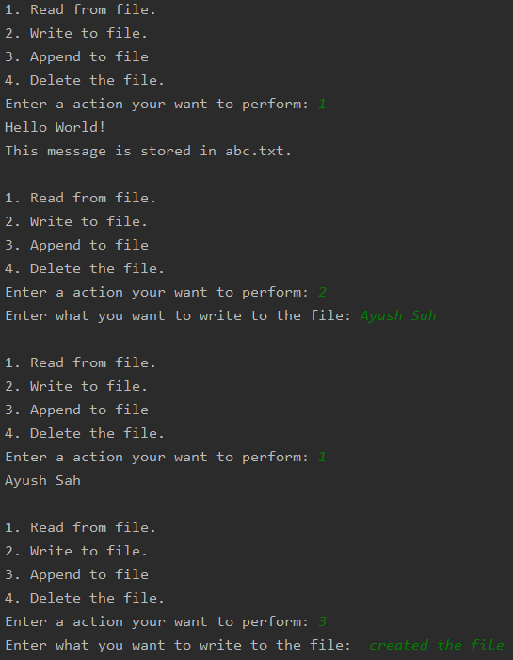

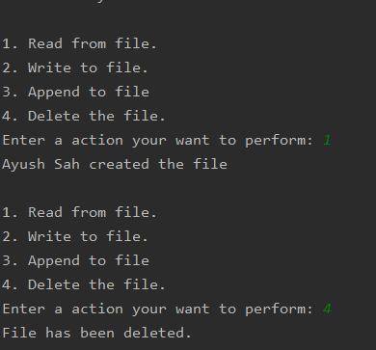

1. **Read a sentence from file and display the content word by word**

**Program:**

file = open("abc.txt", "r")

print("Text in file printed word by word.")

for line in file:

for word in line.split():

print(word)

**Output:**

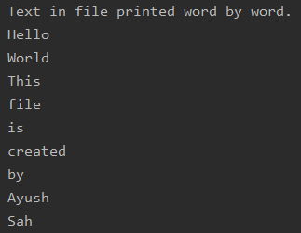

**3. Organize files on your system by file type(Extension)**

**Program:**

import os

import shutil

path='Organize/'

list = os.listdir(path)

for file in list :

file_name,extension=os.path.splitext(file)

extension=extension[1:]

if extension == "" :

continue

if os.path.exists(path+"/"+extension):

shutil.move(path+"/"+file,path+"/"+extension+"/"+file)

else:

os.makedirs(path+"/"+extension)

shutil.move(path+"/"+file,path+"/"+extension+"/"+file)

**Output:**

**Before Organizing:**

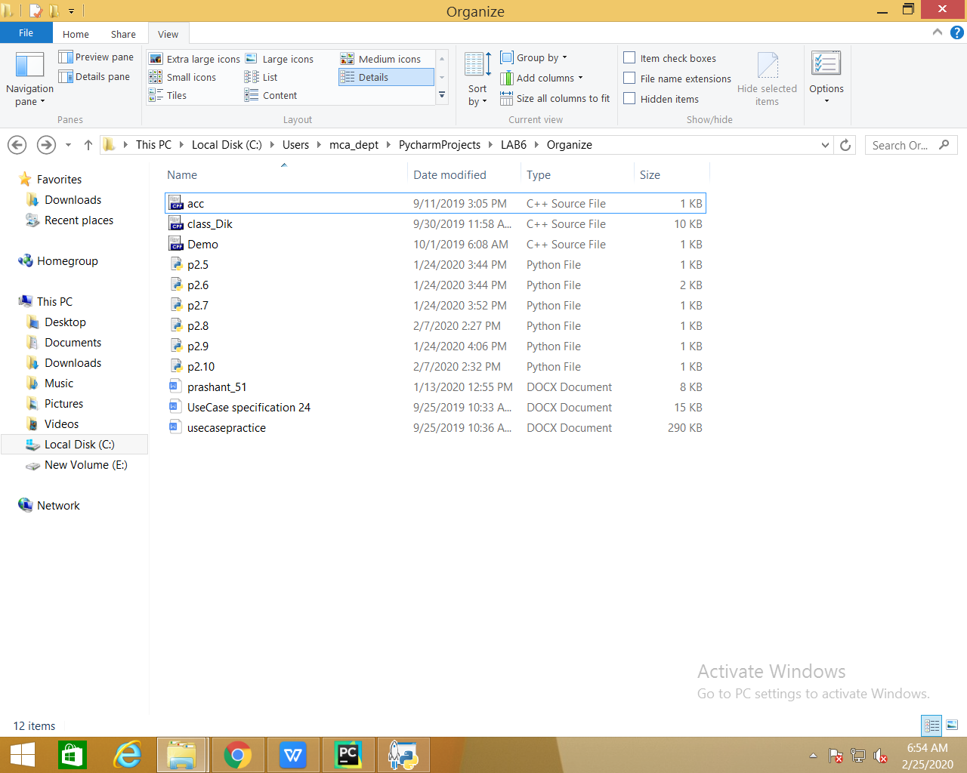

**After Organizing:**

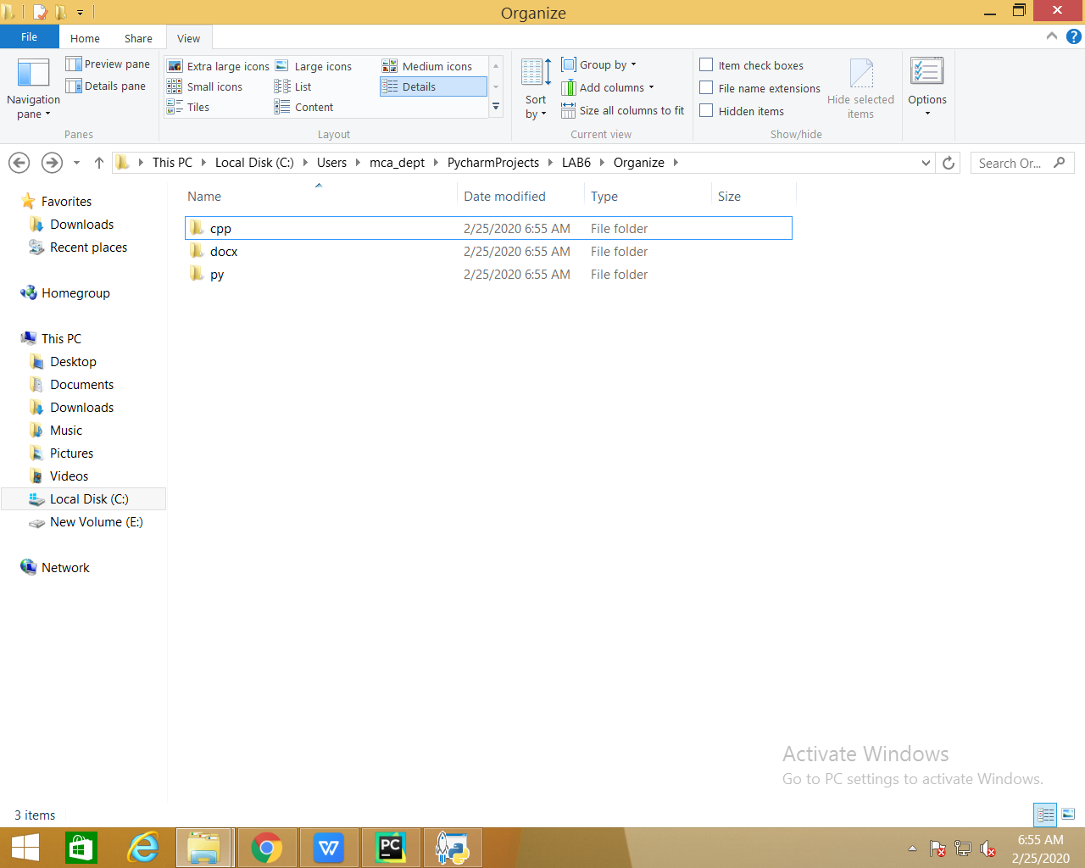

**4. Perform various operations on Excel File by importing xlrd module**

**Program:**

#import xlrd

file = xlrd.open_workbook("student.xlsx")

sheet = file.sheet_by_index(0)

print("Total Rows = ", sheet.nrows, "\nTotal Columns = ", sheet.ncols)

print()

for i in range(sheet.nrows):

for j in range(sheet.ncols):

print(sheet.cell_value(i, j), end="\t")

print()

num = int(input("\nEnter Sr. no. whose data you want to display: "))

print()

print("Displaying data of student with Sr. : ", sheet.cell_value(num, 0))

print("Student name is: ", sheet.cell_value(num, 1))

print("Student marks in OS is: ", sheet.cell_value(num, 2))

print("Student marks in Python is: ", sheet.cell_value(num, 3))

**Output:**

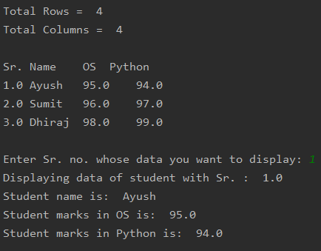

**5. Write a program which handles built in exceptions**

**Program:**

class calculator:

def __init__(self, value):

self.value = value

def __add__(self, other):

return self.value + other.value

def __mul__(self, other):

return self.value * other.value

def __sub__(self, other):

return self.value - other.value

def __truediv__(self, other):

return self.value / other.value

def __mod__(self, other):

return self.value % other.value

def __pow__(self, other):

return self.value ** other.value

def __lt__(self, other):

if self.value < other.value:

return "ob1 is less than ob2"

else:

return "ob2 is less than ob1"

def __eq__(self, other):

if self.value == other.value:

return "Both are equal"

else:

return "Both are not equal"

val1 = calculator(2)

val2 = calculator(3)

print("Addition of objects: ", val1 + val2)

print("Subtraction of objects: ", val1 - val2)

print("Multiplication of objects: ", val1 * val2)

print("Division of objects: ", val1 / val2)

print("Remainder of objects: ", val1 % val2)

print("Power of objects: ", val1 ** val2)

print("Comparison of objects: ", val1 < val2)

print("Checking equality of objects: ", val1 == val2)

**Output:**

